Medela:

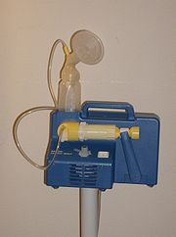

Lactina Select Pump
Assembly: PHFE WIC Video English PHFE WIC video Spanish

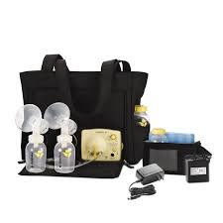
Pump In Style - Personal Pump
Medela Video: English Spanish

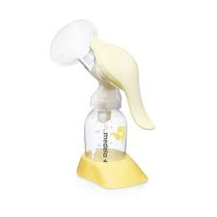
Harmony Manual Pump
Assembly: Medela Video (English) Medela Video (Spanish)

Assembling manual pump from Lactina attachment kit: PHFE WIC Video English

Medela Pump Cleaning FAQ: Link

Hygeia:

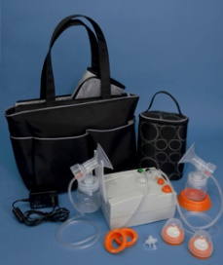

EnJoye Lithium Ion Battery (LBI) Pump
Assembly & Use: Stanislaus Co. WIC Video (English), Hygeia Video (English),
Hygeia Video Spanish (Spanish)
Quick Start Guide (PDFs): English , Spanish

Ameda:
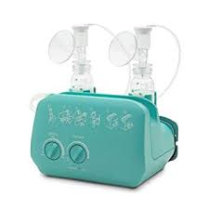
Elite Pump
Assembly & Use: Ameda Video (English) start at 7.00 minutes Spanish
User manual: PDF (Multiple languages)

Assembling a manual pump from Elite attachment kit: CAP Kern WIC Video (English)

