HIV/AIDS Program
Annual Report

January - December 2017

Prepared by
Ventura County Public Health
The HIV/AIDS Center
Office of HIV/AIDS Surveillance

TABLE OF CONTENTS

2017 Ventura County HIV/AIDS Report

- Introduction………………………………………………………………………………………………………………....…3

- The Center 4

- Cumulative AIDS cases and AIDS deaths 1985-2017 5

- Ventura County HIV cases 6

  - Summary 2017 HIV cases 6

- Ventura County AIDS cases 7

  - Summary 2017 AIDS cases 7

- Expanded HIV Testing Grant……………………………………………………………………………………………. 8

- Ventura County “Out of County” (OOC) cases 9

- Summary 2017 cases and goals for 2018………………………………………………………………………….10

- Attachment A: CDC Revised HIV Testing Recommendations in the Healthcare Setting….…11

- Attachment B: Ventura County HIV/AIDS map- cumulative cases…………………………………….12

Introduction
The Center for Disease Control (CDC) in conjunction with the current National HIV/AIDS Strategy, Healthy People 2020 and the California State Office of AIDS provide us with the outline and strategy to combat the HIV/AIDS epidemic.
The strategy sets clear priorities and targets for HIV prevention and care in the United States, and calls on government agencies and their public and private partners to align efforts toward a common purpose.
The following are the goals for the next 5 years:
1) Lower the number of new HIV infections by 25%.
2) Increase percentages of people living with HIV who have knowledge of their infections from 79 to 90%.
3) Reduce the HIV transmission rate by 30%.
4) Increase percentage of newly diagnosed people linked to care within 3 months from 65 to 85%.
5) Increase the proportion of HIV-diagnosed gay and bisexual men, African Americans, and Latinos
with undetectable viral load by 20%

California

California’s 2017 to 2021 Integrated HIV Plan establishes a blueprint designed as a guide towards reaching Zero for state and local health departments. The California’s Integrated HIV Surveillance, Prevention, and Care Plan for Laying the Foundation to Getting to Zero may be found at https://www.cdph.ca.gov/Programs/CID/DOA/CDPH%20Document%20Library/IP_2016_Final.pdf

Getting to Zero means that there are

- Zero new HIV infections,
- Zero AIDS related deaths, and
- Zero stigma and discrimination against people living with HIV.

Ventura County
Ventura County Public Health (VCPH) follows the National HIV/AIDS strategy (updated to 2020), the CDCs High-Impact Prevention (HIP) approach to reducing new HIV infections, and California’s Integrated Plan for Getting to Zero. The VCPH department has adopted or embraced the Centers for Disease Control and Prevention’s (CDC) high impact HIV prevention strategies of providing simple, accessible, routine HIV testing, HIV care and treatment, easy access to condoms and Pre-Exposure Prophylaxis (PrEP), risk reduction support, and partner services.

- Opt-Out Testing: Educate providers on the CDC recommendation that suggests Healthcare providers adopt a policy for routine HIV screening for patients 13-64 yrs., and all pregnant women in all healthcare settings.

- HIV Care and Treatment: Attempts to be present during initial disclosure of HIV diagnosis to patients are made and immediate case management services and linkages to care are offered. This strategy has proven to be very successful in Ventura County and has been an adopted practice by other counties. Linking to HIV care and treatment are critical elements in reducing transmission of HIV and associated healthcare costs.

- Access to condoms: Condoms are made accessible at multiple sites throughout the county. These sites include those that have been identified by the VCPH Sexually Transmitted Infections (STI) collaborative as high-risk locations. Transmission of HIV is reduced through the use of condoms.

- PrEP (Pre-Exposure Prophylaxis) availability and Uptake: Providing pre-exposure medication to individuals at risk for HIV infection reduces the risk of transmission. Unfortunately, 34% of primary health care providers recently reported not having heard of PrEP. Ventura County Public Health and its partners are researching how to increase the percentage of PrEP providers.

- Risk Reduction Support: Through outreach, counseling and testing we educate Individuals with the information and resources needed to protect themselves and their partners.

- Partner Services: A service that assists people with HIV in notifying sex and/or needle sharing partners of a possible exposure to HIV. Partner Services is voluntary, confidential and free.

VENTURA COUNTY PUBLIC HEALTH
“THE CENTER”

What We Do
The Center, located in the city of Ventura, strives to improve the lives of people with HIV/AIDS; emotionally, socially and biologically. The Center provides medical case management to HIV infected and affected people of Ventura County regardless of ability to pay, sexual orientation, documentation, ethnicity, gender, or religious convictions. We provide professional, confidential, and culturally sensitive services primarily in English and Spanish, and other languages as needed.
We Are Unique
Ventura County Public Health HIV/AIDS services has a unique method for getting newly diagnosed patients directly into care. The State Office of AIDS has recognized these strategies and has encouraged other counties to follow our lead.

Intense efforts are made for an HIV case manager to be with the healthcare provider and patient at the time of HIV diagnosis disclosure. We remain with the patient; providing emotional support and direct linkage to an HIV specialist. It is critical that the patient leave the provider’s office with a plan to move forward and know they have a support system already in place. This has been highly successful in getting patients into care within one day to one week and retaining them in care. This enhances their health outcome, reduces HIV transmission rates, creates an early opportunity for HIV viral suppression, supports health care providers and reduces associated healthcare costs.

VCPH HIV/AIDS services include:
- Medical Case Management
- AIDS Drug Assistance Program (ADAP)
- Partner Services (PS)
- Early Intervention Services (EIS)
- Office of AIDS Health Insurance Premium Payment Program (OA-HIPP)
- Court Mandated HIV/AIDS Education
- HIV/AIDS Case Surveillance
- HIV/AIDS-Related Reports and Presentations
- Syringe Replacement Program (SRP)

CDC data suggests an average of 46,000 new HIV infections per year
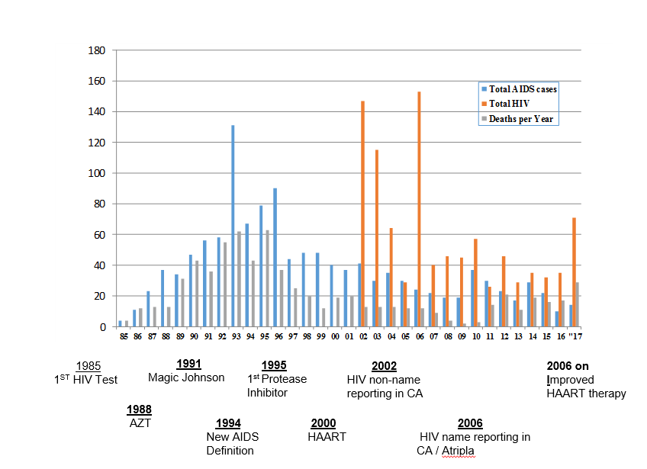

Summary 2017 HIV Cases
- There was a total of 71 new HIV infections.
- 86% were men having sex with men (MSM); 14% heterosexual transmission
- 28% were < 25 yrs. of age, 29% were between 26-35 years of age, 15% between 36-45 years of age, 28% were over 45
- 49% were white; 45% Hispanic; 1% African American and 5% other.
- Several cases were diagnosed in Los Angeles but lived in Ventura County.

Summary 2017 AIDS CASES
- There was a total of 14 newly diagnosed AIDS cases.
- 12 were males with 90% men having sex with men; 2 were heterosexual females
- 21% were white; 76% Hispanic; 3% were other.
- 100% were diagnosed simultaneously with HIV and AIDS = late diagnosis, higher medical costs, increased likelihood of HIV transmission and poorer health outcome.
- 7% were under the age of 25 yrs.; 36% between the ages of 35-45 yrs.; 57% were over 50 yrs. of age.
- Additionally, 11 cases transitioned from HIV to AIDS.

EXPANDED HIV TESTING GRANT
According to the CDC, more than 1.1 million people are infected with HIV in the United States and one in six people or 15.8% are unaware of their diagnosis. The 2017 HIV/AIDS report from Ventura County Public Health notes that there are approximately 2,188 people diagnosed and living with HIV/AIDS in Ventura County. Following CDC estimates, likely 15.8%, or at least another 345 patients remain undiagnosed and unaware of their diagnosis. In 2017, 100 % of the people diagnosed with AIDS in Ventura County were diagnosed simultaneously with HIV, which remains higher than the national average.

In March 2015, VCPH HIV/AIDS Program participated in collaboration with PAETC (Pacific AIDS Education and Training Center) in the Expanded HIV Testing Program (EHT) provided by the State Office of AIDS. Routine screening for HIV began in the county hospital Emergency Departments (ED) located at the VCMC Santa Paula and Ventura campuses. The grant ended in December 2017, however, the screenings are continuing and there are expansion efforts underway to St. John’s Regional Medical Center ED.

The 2017 EHT Grant results include:

- 47 positive HIV tests; 7 were newly diagnosed. The seven newly diagnosed patients (2 of the 7 were homeless) were contacted, given their results and linked to care immediately. Partner notifications were also performed.

- 8 patients were out of care and linked back into medical and case management services.

- A total of three cases were indeterminate. This means they were reactive for HIV 1/2 Ab Ag, however, the confirmatory test was not reactive. This could mean a person is actively seroconverting (a recent exposure has occurred) or it may be a false positive test. In this situation a PCR HIV viral load test is needed confirm the results. All three of these cases turned out to be negative for HIV. Patients were contacted with the results and HIV education and prevention were provided.

It is critical to identify HIV positive patients, get them into care, on HIV medications, and identify who also may be at high risk for HIV transmission. The EHT grant also provided an opportunity to re-connect patients who dropped out of care back into services; reducing HIV transmission rates, and potential hospitalizations—aligning with the 2013 through 2020 National HIV Care Continuum Initiative.

OUT OF COUNTY, STATE and COUNTRY CASES
(OOC/OOS)

OOC cases are those patients who were diagnosed and reported in another county, state or country and are now living and receiving HIV/AIDS services in Ventura County. The Center does not receive state or federal funds for these patients, however still provide services to this population. Many of our OOC are from neighboring counties such as Los Angeles, which has one of the largest populations of HIV/AIDS cases.

In 2017, 41% of individuals receiving HIV/AIDS services in Ventura County were from out of state and 17% were from other California counties.

Summary
There was a significant increase in the number of HIV cases in 2017 (71 vs. 35 in 2016). Most of these were young men under the age of 35, both White and Hispanic. The means of transmission was primarily men having sex with men. Many of those infected were connecting via geosocial networking mobile apps on their phones or the internet. Easy access to sex and drug use with anonymous partners continues to be a challenge. Of interest, the cities of San Francisco and Berkeley are attempting a pilot program that offers prevention and education messaging on internet sites. Ventura County Public Health is currently working with The State Office of AIDS Prevention branch and community partners to address social media messaging barriers. The spike in new HIV positive cases in 2017 may also be due to increased HIV testing that is encouraged in healthcare facilities throughout Ventura County (see Attachment A)

With the EHT grant, newly diagnosed HIV patients and those previously diagnosed but who had fallen out of care, were linked to services. Although the grant ended December 2017, the work will continue at both Ventura County Medical Center (VCMC) and the Santa Paula EDs. In addition, St. John’s Regional Medical Center will be ensued.

The National goals for early detection and linkage to care have been the focus in Ventura County. The work continues to expand HIV testing, getting newly diagnosed patients into care as soon as possible, and assisting patients to achieve and maintain viral suppression. There are currently six single-tablet medication regimens available. This enhances patient compliance tremendously. HIV and AIDS patients are living longer due to early engagement in medical care, medication, case management assistance and early detection. The Center case managers work with over 350 clients per year. These patients include the newly diagnosed and those who have been living and managing their HIV disease with case management assistance. Our goals of implementing the State Office of AIDS “Getting to Zero” plan into our current prevention practices will continue.

Attachment A
CDC Revised HIV Testing in Healthcare Settings
The CDC recommendations suggest Healthcare providers adopt a policy for routine HIV screening for patients 13-64 yrs. and all pregnant women in all healthcare settings.
New Recommendations: HIV screening
- For patients ages 13-64 years in all healthcare settings after the patient is notified that testing will be performed. The testing will be performed unless patient explicitly declines (Opt-Out screening).
- HIV testing of people at high risk for HIV infection at least once per year.
- Screening should be incorporated into the general consent for medical care; separate written consent is not required.
Why test?
- Data suggests that targeted testing based on risk behavior fails to identify a substantial number of people infected with HIV.
- An estimated one-fourth of the approximately 1 million persons in this country who are living with HIV do not know they are infected.
- Earlier detection and earlier linkage to medical care will allow patients to receive more effective treatment resulting in better improved health and extended health. Currently, many only learn of their diagnosis after the onset of symptoms (65%).
- More people accept routine HIV testing if it is offered to everyone (without a risk assessment). This may help reduce the stigma attached.
CDC standard for HIV testing: ELIZA (HIV 1&2 AB)
- Repeatedly reactive enzyme immune-assay (HIV 1 & 2 AB) followed by a confirmatory Western Blot or IFA remains the standard method for diagnosing HIV infection.
- HIV 1 RNA PCR QT viral load should not be used as a screening tool.
- Rapid HIV testing- 20 to 40-minute preliminary result; if positive, confirmatory blood draw required.
NO Consent Required for Testing
California law has eliminated the requirement for separate, written consent for HIV testing.
H&S Code Section 120990 requires a medical care provider, prior to ordering an HIV test, to:
• Inform the patient that an HIV test is planned;
• Provide information about the HIV test;
• Inform the patient that there are numerous treatment options available for a patient who
tests positive for HIV and that a person who tests negative for HIV should continue to be
routinely tested;
• Advise the patient that he or she has the right to decline the HIV test; and, if the patient
declines the HIV test, document that fact in the patient’s medical file.
These bulleted requirements shall not apply when a person independently requests an HIV test from the provider.

Reimbursement: According to the State Office of AIDS
- AB 1894- all private health insurance third party payers must reimburse for HIV testing.
- Medi-Cal should reimburse for ICD-9-CM codes (V73.89 or V69.8)
- Family PACT will reimburse for routine HIV screening
- Medicare will reimburse for individual risk factors and if the patient requests an HIV test.

