2019 SWMHE in Ventura County

MSEL Inject #EX-07

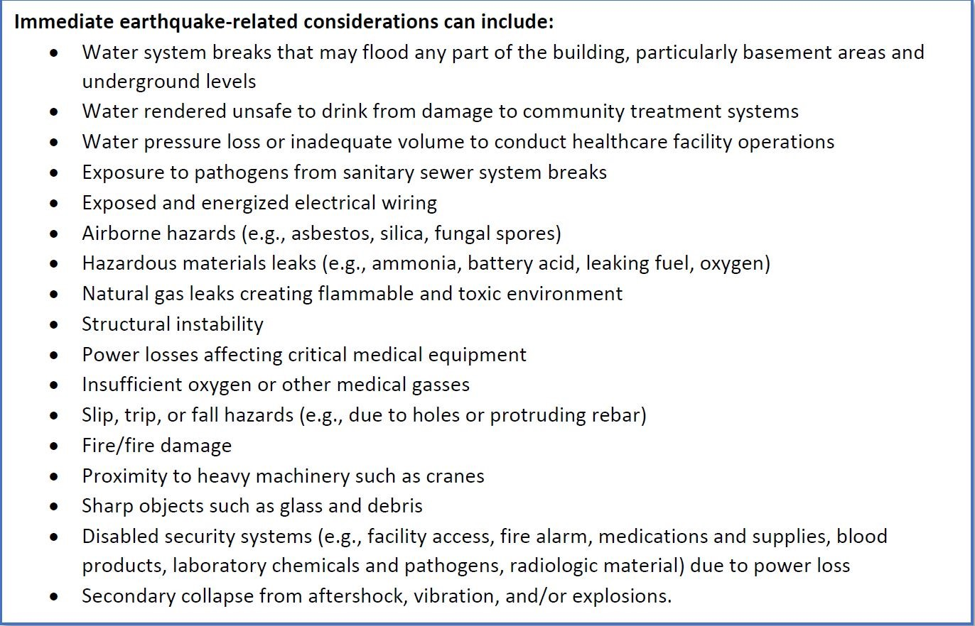

Functioning Utilities:
Gas: | Yes No | Smell or hear gas leaking? Yes No
Water: | Yes No | Leaking or flowing water? Damaged sinks, toilets, or plumbing?  Yes No
Electric: | Yes No | Light fixtures hanging loose, fallen, or exposed wires?  Damaged circuit panels, transformers, other? Yes No
Internet: | Yes No | Is your internet slow or non-functional? Yes No
HazMat: | Yes No | Hazardous chemical leak/spill? Yes No
HVAC: | Yes No | Damaged steam pipes or radiators? Yes No
Other: |  | Elevators stuck or non-functional? Yes No  Are doorways/egress blocked?

