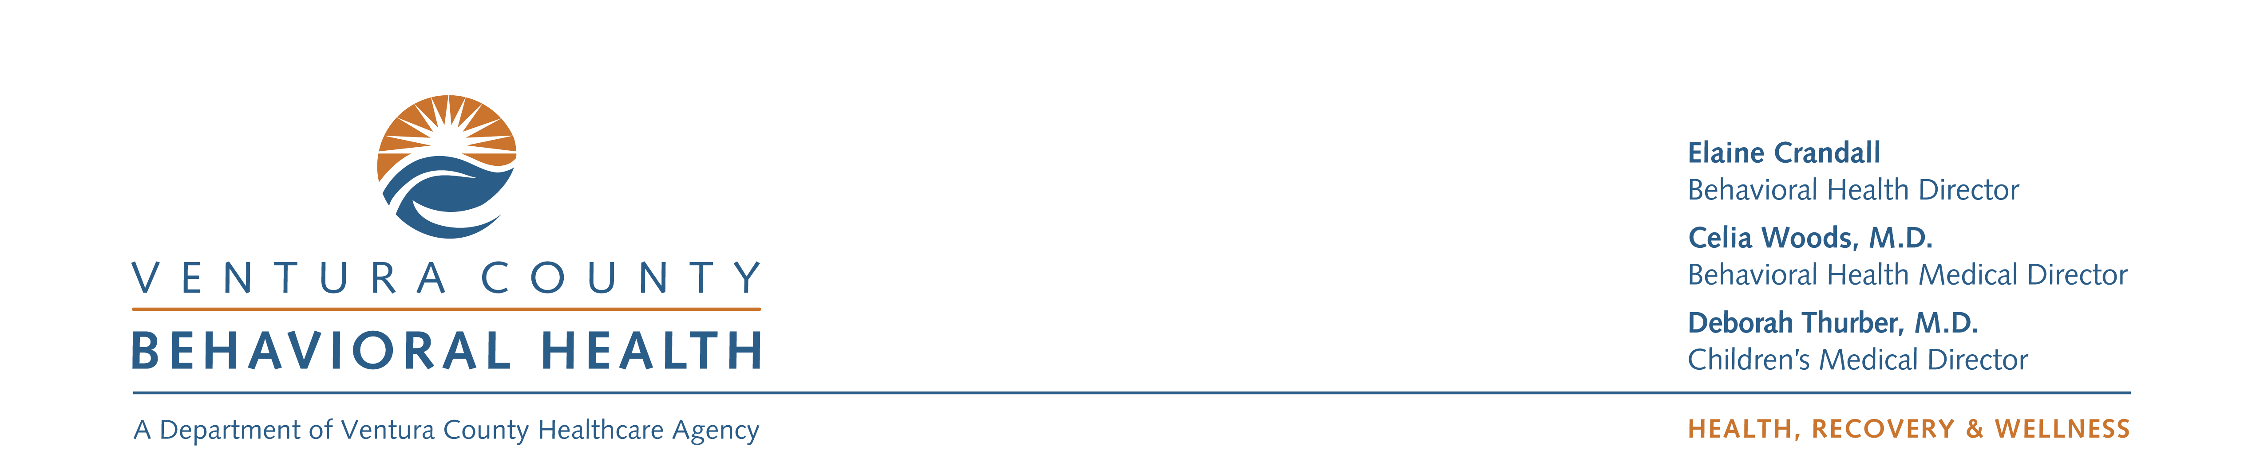

**Ventura County Behavioral Health Department**

Mental Health Services Act (MHSA)

**Innovations: Children’s Accelerated Access to Treatment and Services (CAATS)**

**30 Day Public Comment – March16 -April 14, 2017**

**PUBLIC HEARING – April 17, 2017 1:00 p.m.**

Ventura County Behavioral Health Department

1911 Williams Drive Oxnard, CA 93036

Training Room

Hearing Conducted by Behavioral Health Advisory Board

**Personal Information (optional)**

Name: __________________________________________________________________________________

Agency/Organization: ______________________________________________________________________

Phone Number: _______________________________________ email: ______________________________

Mailing address: ____________________________________________________________________________

**My Role in the Behavioral Health System**

◻ Consumer ◻ Family Member ◻ Probation ◻ Education

◻ Service Provider ◻ Social Services ◻ Law Enforcement ◻ Other: ________________

What do you see as the strengths of this plan?

**What do you see as the strengths of the Plan?**

Comments may be emailed to: MHSA@ventura.org, or mailed to

MHSA Ventura County Behavioral Health Dept. 1911 Williams Drive Suite 200 Oxnard, CA 93036

If you have any concerns about the plan, please explain

**What do you see as the strengths of the Plan?**

**What do you see as the strengths of the Plan?**

**What do you see as the strengths of the Plan?**

**What do you see as the strengths of the Plan?**